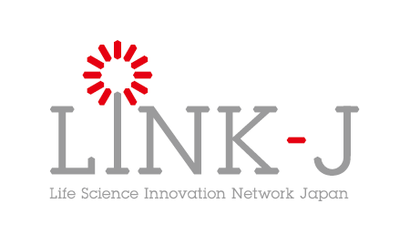
Membership Application Form

Date

To Hideyuki Okano, Chairman of the Board
LINK-J

Address

Trade name or corporation/organization name

Name of representative (Registered representative for a corporation)
Seal

Please place a check mark in all the boxes below:

- We agree with your purpose provided in Article 3 of LINK-J’s Articles of Incorporation, and apply for membership as a Special Member in order to participate in activities based on the purport.
<Excerpt from Article 3 of Articles of Incorporation>
The purpose of LINK-J is to create the spaces for the exchange of people around the world who are involved with broadly-defined life-science studies or industries in the Nihonbashi district and establish the platforms which continue to generate products and services contributing to people’s health.

- We pledge that we comply with laws and any other rules or regulations provided by LINK-J.

- The applicant and its directors or officers are not the Anti-Social Forces provided in Article 20 of your Special Membership Rules.

- We consent to the Basic Policy on Protection of Personal Information and the Purpose of Use of Personal Information separately provided by LINK-J.

- We consent to be presented information such as trade name or corporation/organization name in LINK-J’s brochures, website and others after the application procedures are completed.

