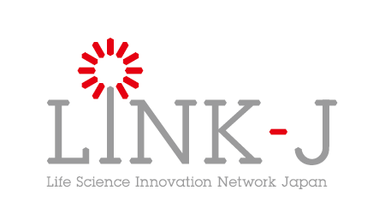
Membership Application Form

Date

To Hideyuki Okano, Chairman of the Board
LINK-J

Address

Name [Seal]

Please place a check mark in all the boxes below:

- I agree with your purpose provided in Article 3 of LINK-J’s Articles of Incorporation, and apply for membership as a Special Member in order to participate in activities based on the purport.
<Excerpt from Article 3 of Articles of Incorporation>
The purpose of LINK-J is to create the spaces for the exchange of people around the world who are involved with broadly-defined life-science studies or industries in the Nihonbashi district and establish the platforms which continue to generate products and services contributing to people’s health.

- I pledge that I comply with laws and any other rules or regulations provided by LINK-J.

- I do not belong to the Anti-Social Forces provided in Article 20 of your Special Membership Rules.

- I consent to the Basic Policy on Protection of Personal Information and the Purpose of Use of Personal Information separately provided by LINK-J.

